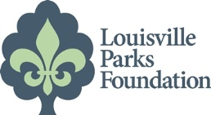
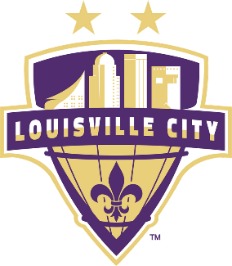
FOR IMMEDIATE RELEASE  April 23, 2019 | Erika Nelson  502/445-3024  enelson@louisvilleparksfoundation.org  Howie Lindsey  502/568-2489  Howie@louisvillecityfc.com
LouCity FC staff running the miniMarathon to raise funds for turf soccer field in Wyandotte Park
Winners for Wyandotte

LouCity FC staff and supporters have committed to run in the Kentucky Derby Festival’s miniMarathon on April 27, in support of the Louisville Parks Foundation’s planned turf soccer fields at Wyandotte Park. The LouCity runners include Club President Brad Estes, Coach John Hackworth and Community Relations Director Mario Sanchez, in addition to other park and soccer enthusiasts, all of whom are competing to be declared the “Winner for Wyandotte.”

In 2018, the Louisville Parks Foundation (LPF) and LouCity FC committed to raising funds to install a total of five artificial turf soccer fields in three South Louisville parks. These will mark the first set of turf fields in Louisville’s public parks system.
Since June 2018, a 5-a-side field at Beechmont Community Center and a larger (125’ x 225’) field in William Harrison Park have been completed. Wyandotte Park is scheduled to receive three (3) 5-a-side soccer fields that will be open to the public in Fall 2019.
“When we were kicking around ideas on how to raise funds for the soccer field project, we figured a little competition between staff would be fun,” said Mario Sanchez, LouCity FC Director of Youth Development and Community Outreach. “We are already hosting soccer clinics at the two new fields and I see people from all over the city coming out to play soccer. This is what it’s all about. Having fields that are accessible to the public and encourage fun and exercise.”
“Louisville City FC is a tremendous partner. We couldn’t have gotten this far on this project without them,” said Brooke Pardue, Louisville Parks Foundation CEO. “When they said they are invested in the community, they mean it!”
People can choose the staffer they would like to support online at, https://www.lpfky.org/donate-lou-city-challenge.
About the Louisville Parks Foundation:
The Louisville Parks Foundation (LPF)’s mission is to inspire donors to invest in our 120+ public parks and recreational facilities – for present and future generations. LPF was formed as a non-profit in December 2005 to support parks and community programs not funded by other local non-profits. In 2013, the Louisville Jack O’Lantern Spectacular opened and the producers of the show partnered with the Louisville Parks Foundation, which became the recipient of the proceeds. Since then, the Foundation has completed major projects in California, Lannan, and Russell Lee parks, installed a 5-a-side turf soccer field at Beechmont, an 8-a-side turf soccer field at William Harrison, and built the first “Skate Spot” in the Midwest at Breslin Park. The Foundation is currently raising funds for its final phase of additional turf soccer fields in South Louisville at Wyandotte Park. For more information, visit www.lpfky.org.

