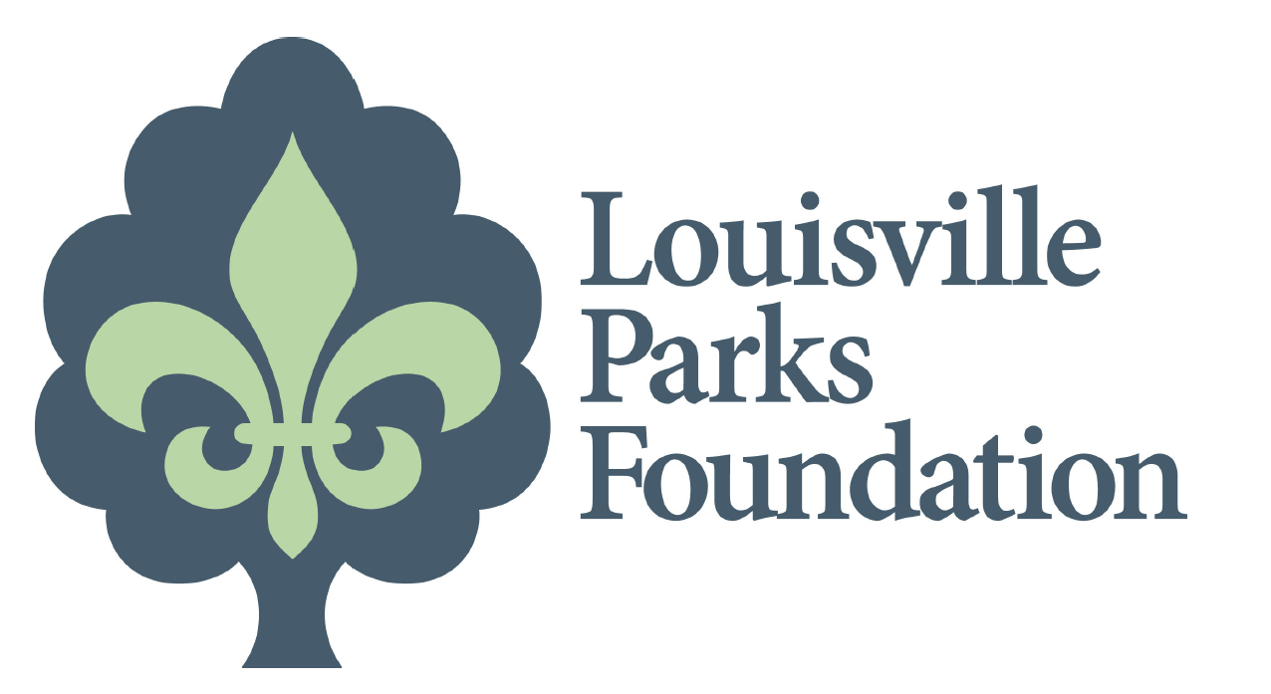

Summer Blessings Feeds Low-Income Youth at

Louisville Parks & Recreation Community Centers

LOUISVILLE, KY. (May 23, 2018) - On Wednesday, May 23, the Louisville Parks Foundation partnered with Texas Roadhouse and Blessings in a Backpack to pack 8,000 food packages at the South Louisville Community Center.

Summer Blessings was founded in 2016, by Texas Roadhouse associates LaShelle LeMaster and Paula Logue. The program complements Blessings in a Backpack which provides food packages to low-income children through the school system, however there was no system to serve the children during the summer months. By working with Louisville Parks and Recreation, they were able to provide weekend meals to the children attending summer programs at three Community Centers.

In 2017, the program was expanded to fill 3,600 bags for children at six different community centers. Each bag contains about seven food items including canned ravioli, spaghetti and meatballs, fruit cups, and crackers.

“We’ve seen the impact and want to help even more children,” Paula says. “As restaurant operators, we have the ability and resources to collectively make an impact on hunger in our community.”

In 2018, the Louisville Parks Foundation provided funds to expand the program to feed 1000 children attending all thirteen Community Centers.

“We are happy our contribution has made it possible to expand this program from six community centers to all thirteen,” said Brooke Pardue, CEO of the Louisville Parks Foundation. “Helping to create a healthy community is part of what we do.”

Summer Blessings sponsors include Texas Roadhouse, Louisville Parks Foundation, Sysco, The Oliver Group, Louisville Parks & Recreation, PrintTex USA and Coca-Cola

