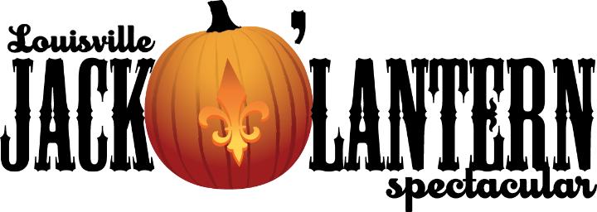
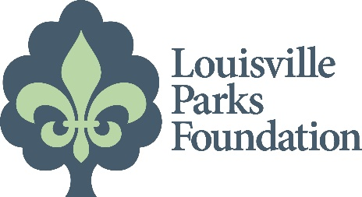
For Immediate Release:  October 9, 2018 | Erika Nelson  502/445-3024  enelson@louisvilleparksfoundation.org

Jack O' Lantern Spectacular returns
to Iroquois Park for sixth consecutive year
5,000 artistically carved pumpkins to light walking trail

In what has become the must-see event of the Halloween season, the Jack O’ Lantern Spectacular is returning for the sixth consecutive year to south Louisville’s Iroquois Park, where 5,000 artistically carved pumpkins will greet visitors from October 9 through November 4.
The pumpkins will illuminate a 1/3-mile trail adjacent to the Iroquois Amphitheater, and event officials estimate up to 85,000 people will visit.
The trail is open from dusk until 11 p.m., Sunday through Thursday, and until midnight on Friday and Saturday nights. Tickets range from $10 to $17, with discounts for seniors and children 12 and under. Proceeds from the event benefit the Louisville Parks Foundation.
The wooded trail begins just outside of Iroquois Amphitheater (1080 Amphitheater Road, Louisville, KY 40214) and weaves its way through the trees with themed vignettes set to music. The carved, lit pumpkins rotate on a weekly basis, creating a different experience each weekend. This year’s show, “A Night at the Library”, is a celebration of the Smithsonian’s 50th anniversary with skits highlighting imagery from literature, pop culture, history, arts and cinema.

Concessions will be available nightly, including the sale of Parkside Coffee, a specialty blend created and roasted locally by Fante’s Coffee, with proceeds benefiting the Louisville Parks Foundation. Merchandise such as t-shirts and hats will also be available for sale, marking the first-time commemorative items are being offered.

The event is held rain or shine. Coach drop-off and on-site parking is available.

Jack O' Lantern Spectacular is produced by the Louisville Parks Foundation and The Iroquois Amphitheater in conjunction with Passion for Pumpkins, a multimedia production company with more than 30 years' experience in redefining fall by transforming any landscape into an illuminated organic gallery.

This year’s sponsors include Louisville Tourism, Papa John’s, Republic Bank, LG&E and KU, Louisville Metro Council, Speed Art Museum, Porta Kleen, Waste Management, Metro Fence, Wendy’s, Girl Scouts of Kentuckiana, Louisville Eye Center, WeatherCheck, Frazier History Museum, Wendy’s, Yellowstone Select Bourbon, Old 502 Winery, and Bristol Catering.
TICKET INFORMATION
Sunday – Thursday
Adults $13
Seniors (62+) $11
Children (3-12) $10
Friday – Saturday
Adults $17
Seniors (62+) $14
Children (3-12) $13
Individual tickets may be purchased in advance for specific nights at the Iroquois Amphitheater Box Office or online at www.jackolanternlouisville.com. Visitors are also encouraged to use the hashtag #502Pumpkins on social media to share images or experiences they enjoy while touring the show.
Tickets for groups of 20 or more can be purchased in advance by calling 502/368-5063, or in person at the Iroquois Amphitheater Box Office at 6 p.m. beginning October 9.
Group tickets are discounted at $10 Sunday through Thursday.
The event is held rain or shine. No refunds will be given, but advanced purchased tickets may be exchanged for another day.
NOTE TO EDITORS: To request images, logos or brochures contact Erika Nelson at enelson@louisvilleparksfoundation.org, 502/445-3024.
ABOUT THE PARTNERS
The Louisville Parks Foundation (LPF)’s mission is to inspire donors to invest in our 120+ public parks and recreational facilities – for present and future generations. LPF was formed as a non-profit in December 2005 to support parks and community programs not funded by other local non-profits. In 2013, the Louisville Jack O’Lantern Spectacular opened in Iroquois Park and the producers of the show partnered with the Louisville Parks Foundation, which became the recipient of the proceeds. Since then, the Foundation has completed major projects in California, Lannan, and Russell Lee parks, installed a 5-a-side turf soccer field at Beechmont, and built the first “skate spot” in the Midwest at Breslin Park. The Foundation is currently raising funds for additional turf soccer fields in South Louisville. For more information, visit www.lpfky.org.

Passion for Pumpkins Inc. is a multimedia production company with more than 30 years' experience in redefining fall by transforming any landscape into an illuminated organic gallery. Begun as a small family run event used to raise funds for the Oxford School department in Massachusetts, the founders of Passion for Pumpkins and their partners have produced "pumpkin shows" in New England, Louisville and Minnesota that have been attended by over a million patrons.

Louisville Parks and Recreation, a nationally accredited parks and recreation agency, manages 120 parks and six parkways on more than 13,000 acres of land, and operates recreation programs for all ages. Its mission, as a Nationally Accredited Parks and Recreation agency, is to connect people to places and opportunities that support and grow a sustainable community. The mission is accomplished by taking care of all parks properties and creating new ones, by providing safe and diverse recreational programs, and by protecting our public lands and resources for future generations. www.bestparksever.com
####

